**Market Maker Trap Trendline Phantoms**

Trendline Phantoms: False Trendlines

Diagonal Trendline Support:

The market begins to make higher highs and higher lows.

The market appears to have a imaginary diagonal line it seems to repel price higher from.

Retail Traders will extend these imaginary lines into the future and attribute support theories to it. When price hits the extended imaginary diagonal line connecting higher lows - Retail **Buys** then.

Diagonal Trendline Resistance:

The market begins to make lower highs and lower lows.

The market appears to have a imaginary diagonal line it seems to repel price lower from.

Retail Traders will extend these imaginary lines into the future and attribute resistance theories to it. When price hits the extended imaginary diagonal line connecting lower highs - Retail **Shorts** then.

Trendlines are based on opinions with no statistical edge

Market sees where large pool of liquidity are, new buy stops new sell stops or old buy stops and sell stops.

Large traders are the prey of the market, thats where the market will go.

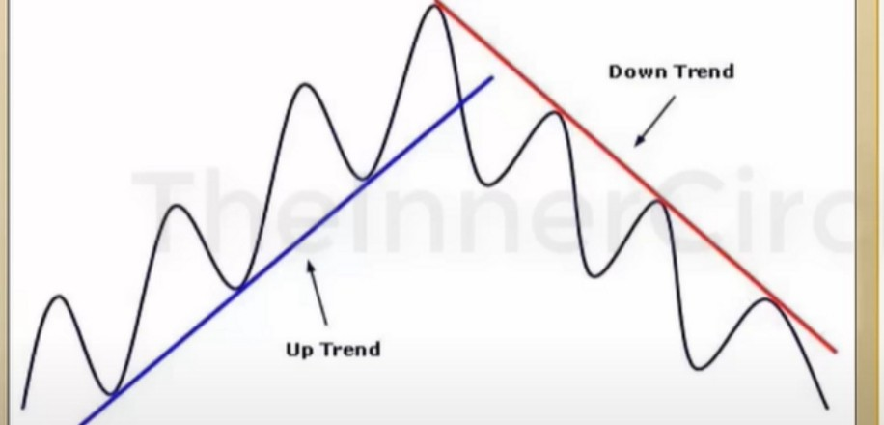

**Trendllne Theory**

**Does price have an awareness of the point of Trendline Support?**

**Do Banks associate "value" or prognostication on the basis of Trendline theory?**

**Is the very nature of Trendlines flawed at its core?**

**How Market Makers capitalize on this fallacy in Price Analysis?**

|  |  |  |  |  |  |  |
| --- | --- | --- | --- | --- | --- | --- |
|  | -.., | ' | ', | ,,  *I* '  *I* '  *I I*  *I I*  1 | I | Retail: Bullish Trendline Support |
| Market Maker Trap: Sell Scenario |
| In periods when price is making higher |
| lows and higher highs, the use of Trendline |
| "Support" will be adopted by Retail |
| Traders. |
| The influx of weakhanded or less informed |
| money at an area or price level - provides |
| liquidity for the Market Maker. |
| The chart may appear bullish but the |
| underpinnings are in fact the opposite. |
| The Retail crowd will buy at a moment |
| when price will be devoid of support. |
| Price will collapse and leave the Retail |
| Trader long with drawdown in the trade. |

ICT looks for an OB or a turtle soup *above* the high after the 2nd touch and before the 3rd touch, especially when we're bearish and were trading at a HTF PD array

There will be a sell scenario there

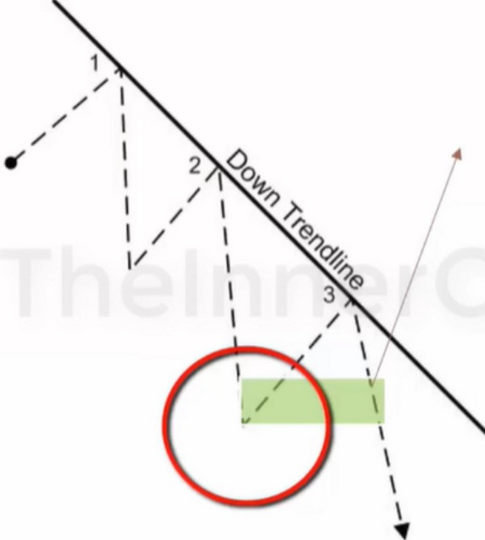

Retail: Bearish Trendline Rec;istanc e

Market Maker Trap Buy Scenario

In periods when price is making lower lows and lower highs, the use of Trendline "Resistance" will be adopted by Retail Traders.

The influx of weakhanded or less informed money at an area or price level - provides liquidity for the Market Maker.

The chart may appear bearish but the underpinnings are in fact the opposite. The Retail crowd will sell at a moment when price will be devoid of resistance. Price will rally and leave the Retail Trader short with drawdown in the trade.

A lot of buy stops will be at the 2nd high, so aim for that

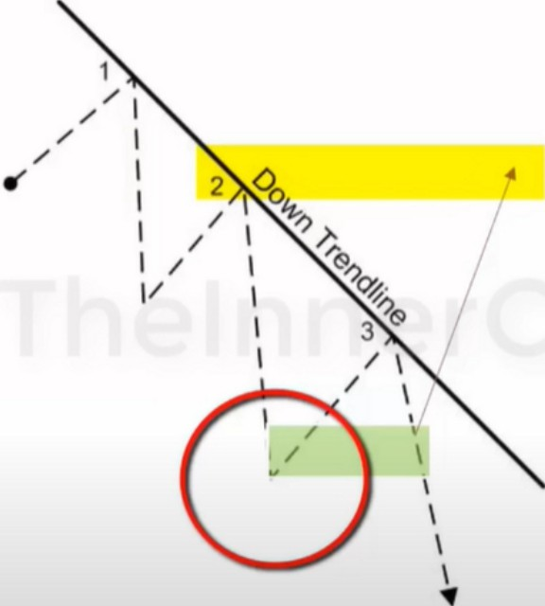

|  |  |  |  |  |  |  |  |  |
| --- | --- | --- | --- | --- | --- | --- | --- | --- |
|  | --., | 1,  I  I I I  ' ,, ,I  1 |  | ', | I  I | ,----  I' I  I | •*I*  *I*  *I* | Retail: Bullish Trend ine Support |
| Market Maker Trap: Sell Scenario |
| In periods when price is making higher |
| lows and higher highs, the use of Trendline |
| "Support" will be adopted by Retail |
| Traders. |
| The influx of weakhanded or less informed |
| money at an area or price level - provides |
| liquidity for the Market Maker. |
| The chart may appear bullish but the |
| underpinnings are in fact the opposite. |
| The Retail crowd will buy at a moment |
| when price will be devoid of support. |
| Price will collapse and leave the Retail |
| Trader long with drawdown in the trade. |

And a lot of sell stops below the 2nd low, so aim for that



Retail. Bearish Trendl e Resis+ancc

Market Maker Trap· Buy Scenario

In periods when price is making lower lows and lower highs, the use of Trendline "Resistance" will be adopted by Retail Traders.

The influx of weakhanded or less informed money at an area or price level - provides liquidity for the Market Maker.

The chart may appear bearish but the underpinnings are in fact the opposite. The Retail crowd will sell at a moment when price will be devoid of resistance. Price will rally and leave the Retail Trader short with drawdown in the trade.

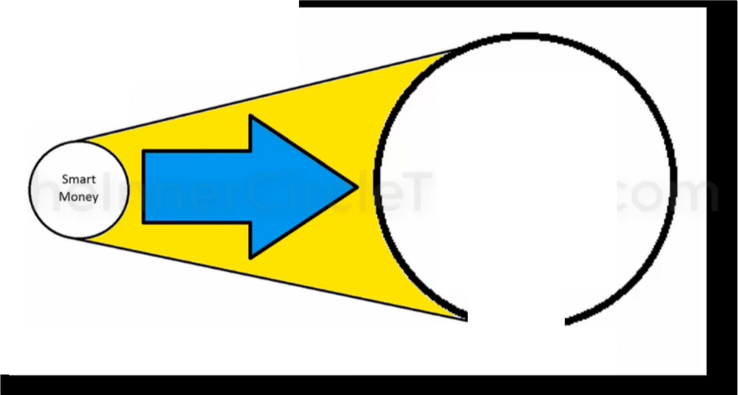

**Price Is Delivered To Engineer Efficiency For Smart Money Entities**

**Liquidity Provider**

**Liquidity**

ThelnnerCircleTrader.com

**WIiiing &/Or UnWllllng Liquidity**

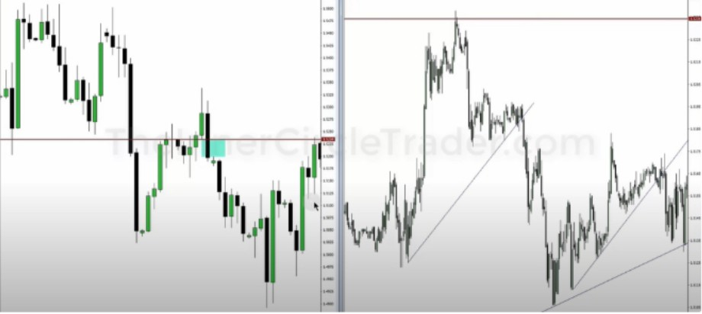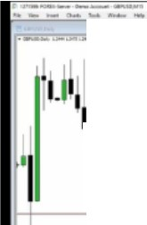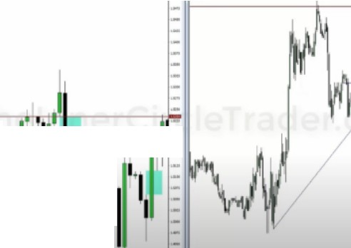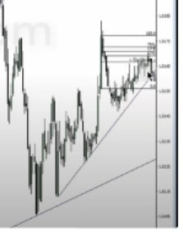

I

u,J")

.I'

1111_!1 -

',­-

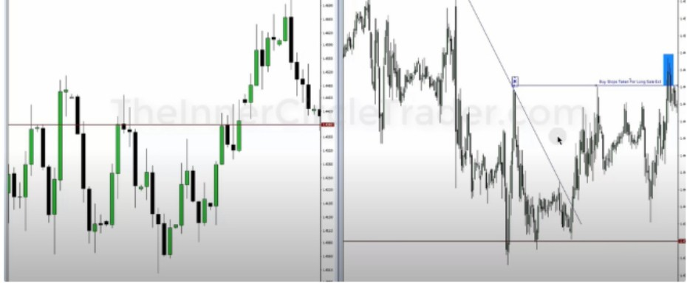Combined with daily PD arrays

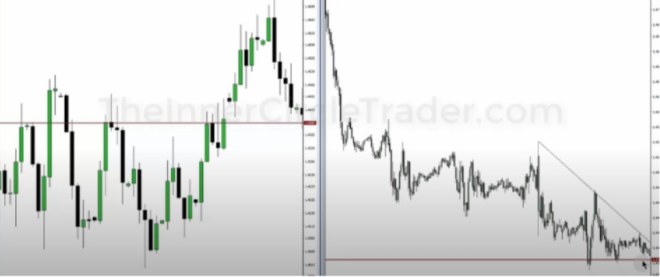



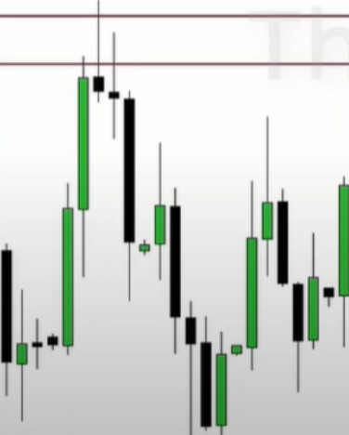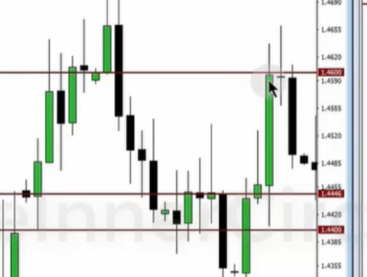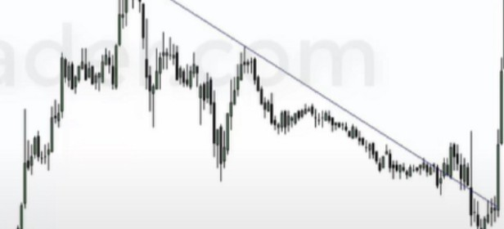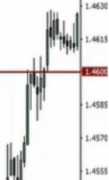

(" **IZTIMFOIWl•S...•Ot. ,i,cc.,.nt•GWUSO.Ottly**

**f"·V-1"..,.Clwffll Windo.**

"""""""

*v*,_ lf-------------;:JIIMc-----hl------------------"L jom,

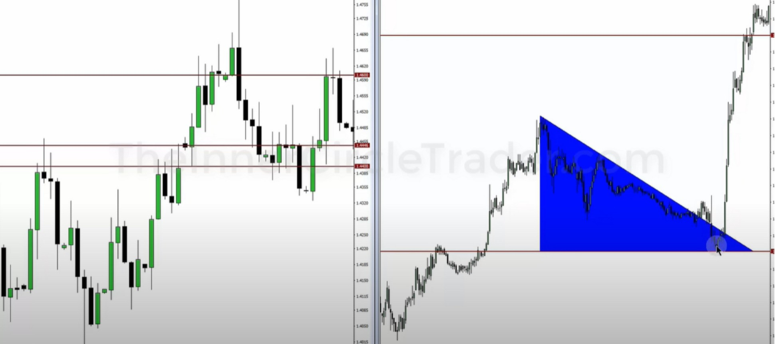Classic chart pattern, triangle

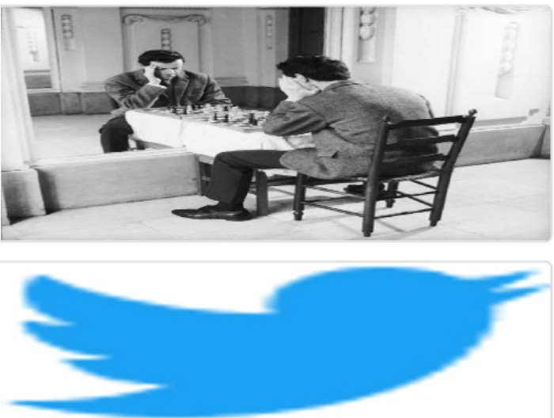Arjo I Twitter, lnstagram I Linktree

Linktree. Make your link do more.

1 https://t.co/HhmmTN1fUI

JavaScript is not available.

***"11*** https://twitter.com/arjoio